Svolgimento esercitazione Data Mining B
Classificazione Multi-Classe con classificatori binari
Docente: Michela Antonelli
Alunno: Mario Canalella, matricola 00122833

Premesse preliminari
Per lo svolgimento della seguente esercitazione ho sviluppo un applicativo Java con interfaccia grafica. Essa permette di selezionare i path dei file CSV in modo da processarli ed analizzarli tramite WEKA.
Per compiere tutto il processo di sviluppo sono stati utilizzati i seguenti componenti software:
- Java 1.8
- Spring Boot 2.6.3
- Weka 3.8.6
- Weka SMOTE 1.0.3
- Maven
Per poter compilare ed eseguire nella propria macchina l’applicativo software occorre avere installato:
- Java 1.8
- Maven
Ed eseguire nel root della cartella del progetto Java i seguenti comandi nel terminale:
- mvn clean install -U
- ./mvnw -X spring-boot:run
In questo modo l’applicativo partirà senza intoppi.
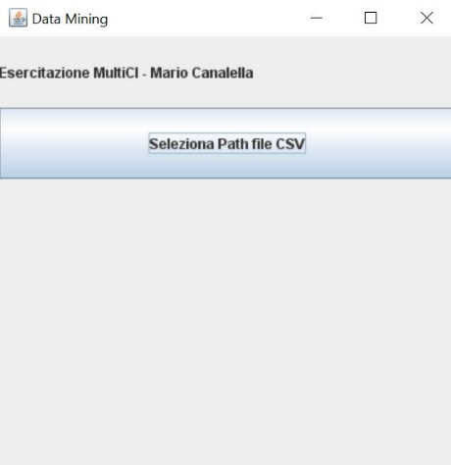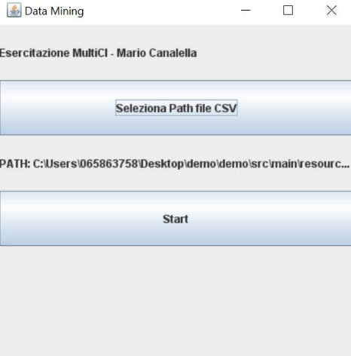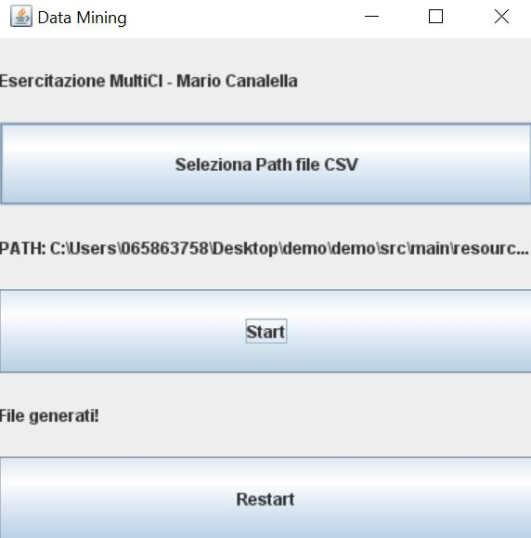
1 2 3
Esso genererà i report e i risultati della classificazione dentro la cartella “resources/irisSingleCl”.

Svolgimento Esercitazione
Punto 1
- Il seguente codice permette di convertire i file CSV presenti nel path selezionato tramite interfaccia nel formato ARFF creando 4 file: 3 file dove Ciascun dataset binario, contenuto nel file i-esimo, ha come istanze della classe positiva tutte le istanze della classe i-esima Ci e le istanze della classe negativa sono tutte quelle delle classi restanti e un quarto file dove sono messe assieme tutte le istanze presenti nei file csv forniti.
private List<String> stepOne(List<String> fileNames) throws Exception {
List<String> fileNamesArff = new ArrayList<>();
List<Instances> instances = new ArrayList<>();
AtomicInteger index = new AtomicInteger();
fileNames.forEach(
file -> {
CSVLoader loader = new CSVLoader();
ArffSaver saver = new ArffSaver();
try {
index.getAndIncrement();
loader.setSource(new File(file));
Instances data = loader.getDataSet();
//REMOVE
data = getInstances(data);
//ATTRIBUTO
FastVector values = new FastVector();
values.addElement("C" + index);
values.addElement("not_C" + index );
data.insertAttributeAt(new Attribute("Class", values), data.numAttributes());
for (int i = 0; i < data.numInstances(); i++) {
data.instance(i).setValue(data.numAttributes() - 1, "C" + index);
}
data.setRelationName("C" + index);
saver.setInstances(data);
String name = (file + ARFF).replace(".csv", "");
saver.setFile(new File(name));
saver.writeBatch();
instances.add(data);
fileNamesArff.add(name);
} catch (Exception e) {
e.printStackTrace();
try {
throw e;
} catch (Exception ex) {}
}
}
);
//CREO IL DATASET METTENDO ASSIEME TUTTE LE ISTANZE PRESENTI NEI CSV
int asize = instances.get(0).numAttributes();
boolean[] strings_pos = new boolean[asize];
for (int i = 0; i < asize; i++) {
Attribute att = instances.get(0).attribute(i);
strings_pos[i] = ((att.type() == Attribute.STRING) ||
(att.type() == Attribute.NOMINAL));
}
Instances multiClasses = new Instances(instances.get(0));
AtomicReference<String> relationName = new AtomicReference<>("");
//ATTRIBUTO
FastVector values = new FastVector();
instances.forEach(instance -> {
relationName.set(relationName + instance.relationName() + "_");
values.addElement(instance.relationName());
});
multiClasses = getInstances(multiClasses);
multiClasses.insertAttributeAt(new Attribute("Class", values), multiClasses.numAttributes());
for (int i = 0; i < multiClasses.numInstances(); i++) {
multiClasses.instance(i).setValue(multiClasses.numAttributes() - 1, "C1");
}
Instances finalMultiClasses = multiClasses;
instances.stream().skip(1).forEach(
istance -> {
DataSource source = new DataSource(istance);
Instances instancs = null;
try {
instancs = source.getStructure();
} catch (Exception e) {
e.printStackTrace();
try {
throw e;
} catch (Exception ex) {}
}
Instance instance;
while (source.hasMoreElements(instancs)) {
instance = source.nextElement(instancs);
finalMultiClasses.add(instance);
// COPIA GLI ATTRIBUTI STRING
for (int j = 0; j < asize; j++) {
if (strings_pos[j]) {
finalMultiClasses.instance(finalMultiClasses.numInstances() - 1)
.setValue(j, instance.stringValue(j));
}
}
}
});
finalMultiClasses.setRelationName(relationName.toString().substring(0, relationName.toString().length() - 1));
ArffSaver saver = new ArffSaver();
try {
saver.setInstances(finalMultiClasses);
saver.setFile(new File(PATH + "\\" + "multiClasses" + ARFF));
saver.writeBatch();
multiClassesFile = PATH + "\\" + "multiClasses" + ARFF;
} catch (IOException e) {
e.printStackTrace();
throw e;
}
//CREO LE CLASSI I-ESIME DOVE LA CLASSE POSITIVA RAPPRESENTANO TUTTE LE ISTANZE DELLA CLASSE I-ESIMA E
//LE ISTANZE DELLA CLASSE NEGATIVA SONO TUTTE QUELLE DELLE CLASSI RESTANTI
index.set(0);
List<String> finalFileNamesArff = new ArrayList<>();
fileNamesArff.forEach(
fileArff -> {
Instances data;
try {
data = new Instances(new BufferedReader(new FileReader(fileArff)));
index.getAndIncrement();
instances.stream().filter(e-> !e.relationName().equals(data.relationName())).forEach(
istance -> {
DataSource source = new DataSource(istance);
Instances instants = null;
try {
instants = source.getStructure();
} catch (Exception e) {
e.printStackTrace();
try {
throw e;
} catch (Exception ignored) {
}
}
Instance instance;
while (source.hasMoreElements(instants)) {
instance = source.nextElement(instants);
data.add(instance);
// COPIA GLI ATTRIBUTI STRING
for (int j = 0; j < asize; j++) {
if (strings_pos[j]) {
data.instance(data.numInstances() - 1)
.setValue(j, "not_C" + index);
}
}
}
});
saver.setInstances(data);
saver.setFile(new File(fileArff + FINAL + ARFF));
saver.writeBatch();
finalFileNamesArff.add(fileArff + FINAL + ARFF);
} catch (IOException e) {
e.printStackTrace();
try {
throw e;
} catch (IOException ignored) {}
}
}
);
return finalFileNamesArff;
}

Punto 2
- Si costruisce il classificatore J48 e i modelli vengono valutati in cross validation (5 fold)
private void stepTwo(List<String> fileNamesArff) {
J48 j48 = new J48();
fileNamesArff.forEach(
fileArff -> {
try {
J48Filter(j48, fileArff);
} catch (Exception e) {
e.printStackTrace();
try {
throw e;
} catch (Exception ignored) {}
}
});
}

private void J48Filter(J48 j48, String multiClassesFile) throws Exception {
try {
Instances data = prepareData(multiClassesFile);
evaluation(j48, data, false);
} catch (Exception ex) {
ex.printStackTrace();
throw ex;
}
}

private Instances prepareData(String instanceFile) throws Exception {
Instances data = new Instances(new BufferedReader(new FileReader(instanceFile)));
DataSource dataSource = new DataSource(data);
Instances instance = dataSource.getDataSet();
if (instance.classIndex() == -1) {
System.out.println("reset index...");
instance.setClassIndex(data.numAttributes() - 1);
}
return data;
}

private void evaluation(J48 j48, Instances instance, Boolean withSmote) throws Exception {
Evaluation evaluation = new Evaluation(instance);
evaluation.crossValidateModel(j48, instance, 5, new Random(1));
String result = evaluation.toSummaryString("Results J48 for " + instance.relationName() + "\n\n", true);
if (withSmote) {
writer = new BufferedWriter(new FileWriter("C:\\Users\\065863758\\Desktop\\demo\\demo\\src\\main\\resources\\irisSingleCl\\resultWithSMOTE" + instance.relationName() + ".txt"));
} else {
writer = new BufferedWriter(new FileWriter("C:\\Users\\065863758\\Desktop\\demo\\demo\\src\\main\\resources\\irisSingleCl\\result" + instance.relationName() + ".txt"));
}
writer.write(result);
writer.close();
}

Risultati ottenuti
Classe C1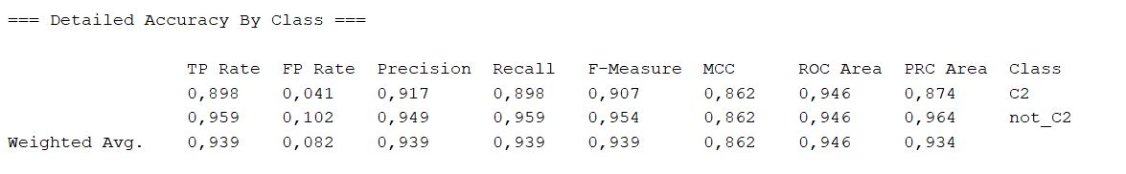
Classe C2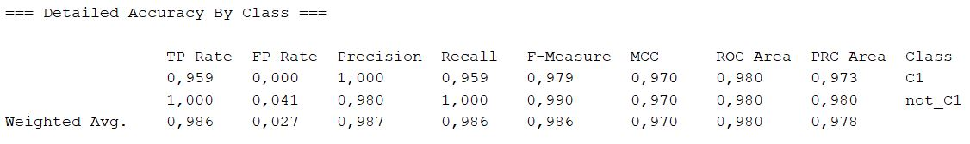
Classe C3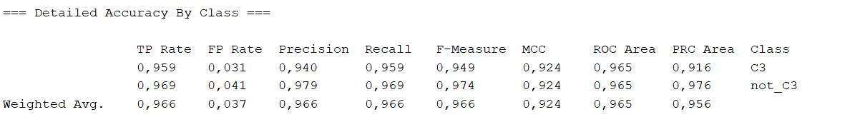
Dai dati analizzati si nota una precisione non variabile per l’affinità tra dati rilevati e dati recuperati e dall’abbassamento di precisione della classe positiva ne consegue un aumento di quella negativa. Inoltre dall’osservazione dei valori delle classi negative emerge che quest’ultime presentano un’elevata recall, confermata anche dai valori del TPR.

Punto 3
Analizziamo il classificatore J48 utilizzando il dataset che si ottiene mettendo assieme tutte le istanze presenti nei file csv forniti.
private void stepThree() throws Exception {
J48 j48 = new J48();
J48Filter(j48, multiClassesFile);
}

private void J48Filter(J48 j48, String multiClassesFile) throws Exception {
try {
Instances data = prepareData(multiClassesFile);
evaluation(j48, data, false);
} catch (Exception ex) {
ex.printStackTrace();
throw ex;
}
}
private void evaluation(J48 j48, Instances instance, Boolean withSmote) throws Exception {
Evaluation evaluation = new Evaluation(instance);
evaluation.crossValidateModel(j48, instance, 5, new Random(1));
String result = evaluation.toSummaryString("Results J48 for " + instance.relationName() + "\n\n", true);
if (withSmote) {
writer = new BufferedWriter(new FileWriter("C:\\Users\\065863758\\Desktop\\demo\\demo\\src\\main\\resources\\irisSingleCl\\resultWithSMOTE" + instance.relationName() + ".txt"));
} else {
writer = new BufferedWriter(new FileWriter("C:\\Users\\065863758\\Desktop\\demo\\demo\\src\\main\\resources\\irisSingleCl\\result" + instance.relationName() + ".txt"));
}
writer.write(result);
writer.close();
}
private Instances prepareData(String instanceFile) throws Exception {
Instances data = new Instances(new BufferedReader(new FileReader(instanceFile)));
DataSource dataSource = new DataSource(data);
Instances instance = dataSource.getDataSet();
if (instance.classIndex() == -1) {
System.out.println("reset index...");
instance.setClassIndex(data.numAttributes() - 1);
}
return data;
}

Risultati
Classe C1_C2_C3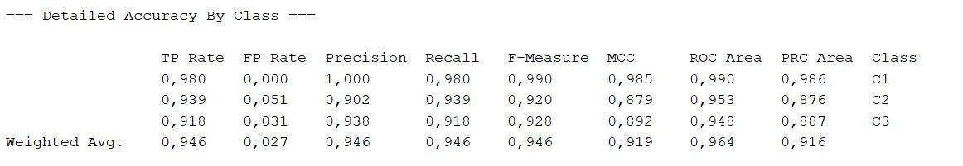
Possiamo notare come nel caso di C1 abbiamo un miglioramento dei valori mentre C2 e C3 un leggero peggioramento per il TRP e la Recall
Punto 4
Aggiungiamo il filtro SMOTE alle classi
private void stepFour(List<String> fileNamesArff) {
J48 j48 = new J48();
fileNamesArff.forEach(
fileArff -> {
try {
J48FilterWithSMOTE(j48, fileArff);
} catch (Exception e) {
e.printStackTrace();
try {
throw e;
} catch (Exception ignored) {}
}
});
}

private void J48FilterWithSMOTE(J48 j48, String multiClassesFile) throws Exception {
try {
Instances data = prepareData(multiClassesFile);
SMOTE smote = new SMOTE();
smote.setInputFormat(data);
Instances dataWithSmote = Filter.useFilter(data, smote);
evaluation(j48, dataWithSmote, true);
} catch (Exception ex) {
ex.printStackTrace();
throw ex;
}
}

private void evaluation(J48 j48, Instances instance, Boolean withSmote) throws Exception {
Evaluation evaluation = new Evaluation(instance);
evaluation.crossValidateModel(j48, instance, 5, new Random(1));
String result = evaluation.toSummaryString("Results J48 for " + instance.relationName() + "\n\n", true);
if (withSmote) {
writer = new BufferedWriter(new FileWriter("C:\\Users\\065863758\\Desktop\\demo\\demo\\src\\main\\resources\\irisSingleCl\\resultWithSMOTE" + instance.relationName() + ".txt"));
} else {
writer = new BufferedWriter(new FileWriter("C:\\Users\\065863758\\Desktop\\demo\\demo\\src\\main\\resources\\irisSingleCl\\result" + instance.relationName() + ".txt"));
}
writer.write(result);
writer.close();
}
private Instances prepareData(String instanceFile) throws Exception {
Instances data = new Instances(new BufferedReader(new FileReader(instanceFile)));
DataSource dataSource = new DataSource(data);
Instances instance = dataSource.getDataSet();
if (instance.classIndex() == -1) {
System.out.println("reset index...");
instance.setClassIndex(data.numAttributes() - 1);
}
return data;
}

Ottieniamo i seguenti risultati:
C1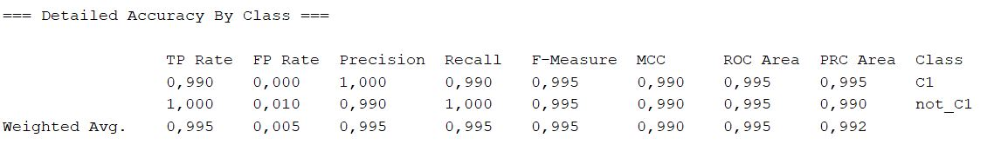
C2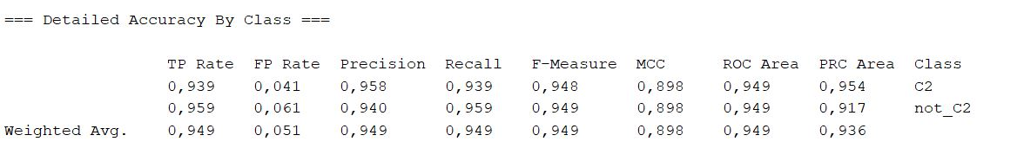
C3
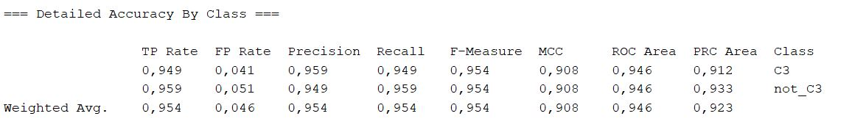
Di cui notiamo che utilizzando il filtro SMOTE e ribilanciando la classe positiva si ha miglioramento della precisione solo nel caso della classe positiva C1.
Punto 5
Costruiamo 2 metaclassificatori che inglobino ciascuno un metodo diverso di attribute selecion (infogain+ ranker (valore infogain >0) e cfsSubsetEval+ best first) applicando a ciascuno il filtro SMOTE.
private void stepFive(List<String> fileNamesArff) {
fileNamesArff.forEach(
fileArff -> {
try {
metaClassifiersCfsSubsetEvalBestFirst(fileArff);
metaClassifiersInfogainRanker(fileArff);
} catch (Exception e) {
e.printStackTrace();
try {
throw e;
} catch (Exception ignored) {}
}
}
);
}

private void metaClassifiersInfogainRanker(String classFile) throws Exception {
// CfsSubsetEval + best first
Instances data = prepareData(classFile);
//APPLICO SMOTE
SMOTE smote = new SMOTE();
smote.setInputFormat(data);
data = Filter.useFilter(data, smote);
//AGGIUNGO ATTRIBUTE SELECTION DEL TIPO cfsSubsetEval + best first
AttributeSelectedClassifier classifier = new AttributeSelectedClassifier();
InfoGainAttributeEval eval = new InfoGainAttributeEval();
Ranker ranker = new Ranker();
ranker.setNumToSelect(Math.min(1, data.numAttributes() - 1));
NaiveBayes nb = new NaiveBayes();
classifier.setClassifier(nb);
classifier.setEvaluator(eval);
classifier.setSearch(ranker);
Evaluation evaluation = new Evaluation(data);
evaluation.crossValidateModel(classifier, data, 5, new Random(1));
String result = evaluation.toSummaryString("Results Infogain + Ranker for " + data.relationName() + "\n\n", true);
writer = new BufferedWriter(new FileWriter("C:\\Users\\065863758\\Desktop\\demo\\demo\\src\\main\\resources\\irisSingleCl\\resultInfogain+Ranker" + data.relationName() + ".txt"));
writer.write(result);
writer.close();
ArffSaver saver = new ArffSaver();
saver.setInstances(data);
saver.setFile(new File("C:\\Users\\065863758\\Desktop\\demo\\demo\\src\\main\\resources\\irisSingleCl\\resultInfogain+Ranker" + data.relationName() + ARFF));
saver.writeBatch();
getAttributeSelectorInfogainRanker(eval, ranker, data);
}
private void getAttributeSelectorCfsSubsetEvalBestFirst(CfsSubsetEval evaluator, BestFirst search, Instances data) throws Exception {
AttributeSelection selector = new AttributeSelection();
selector.setEvaluator(evaluator);
selector.setSearch(search);
selector.SelectAttributes(data);
writer = new BufferedWriter(new FileWriter("C:\\Users\\065863758\\Desktop\\demo\\demo\\src\\main\\resources\\irisSingleCl\\selettoriCfsSubsetEval" + data.relationName() + ".txt"));
writer.write("Selettori CfsSubsetEval + BestFirst data " + data.relationName() + "\n\n");
writer.write(Arrays.toString(selector.selectedAttributes()));
writer.close();
}
private void getAttributeSelectorInfogainRanker(InfoGainAttributeEval evaluator, Ranker ranker, Instances data) throws Exception {
AttributeSelection selector = new AttributeSelection();
selector.setEvaluator(evaluator);
selector.setSearch(ranker);
selector.SelectAttributes(data);
writer = new BufferedWriter(new FileWriter("C:\\Users\\065863758\\Desktop\\demo\\demo\\src\\main\\resources\\irisSingleCl\\selettoriInfogainRanker" + data.relationName() + ".txt"));
writer.write("Selettori Infogain + Ranker data " + data.relationName() + "\n\n");
writer.write(Arrays.toString(selector.selectedAttributes()));
writer.close();
}

